Onboarding Activities
- Download the dataset, the application and the representative periods code
Before this, please ensure you have CANOE/TEMOA downloaded from here:
CANOE-main/temoa at 1.0.0-dev-operator
Please use the 1.0.0-dev-operator branch
The dataset and application are stored on the OneDrive, please contact David Turnbull (David.turnbull1@ucalgary.ca) for access.
The representative periods code is stored at:
CANOE-main/representative_periods: A workflow for rapidly iterating the selection of representative days in the CANOE model
For the dataset and application, simply download it (the correct version of it i.e. windows version or MacOS version). For the representative periods code, use git clone.
Watch the video for installing CANOE and the representative periods code here:

- Run the app on the dataset and representative periods on the output
Access the application and ensure that Current Measures is selected in scenario and click low resolution for New Brunswick and Nova Scotia and name it something relevant like CANOE_ONB.sqlite.
Take the model over to the representative periods directory and set it up with 4 representative periods. Run the code and get the output for the next activities.
- Add IND into the model
At the core of the CANOE model and energy system modeling as a whole is technologies. Technologies convert one commodity to another, whether it is a car converting gasoline to required passenger kilometers, or an electric arc furnace converting electricity into steel. This task is designed to make you comfortable with implementing new technologies into the model.
Currently, our model has two regions, New Brunswick and Nova Scotia. Currently both regions have a demand for industry but way to meet them. You need to create an annual technology for the model based on the two schematics below.
New Brunswick:
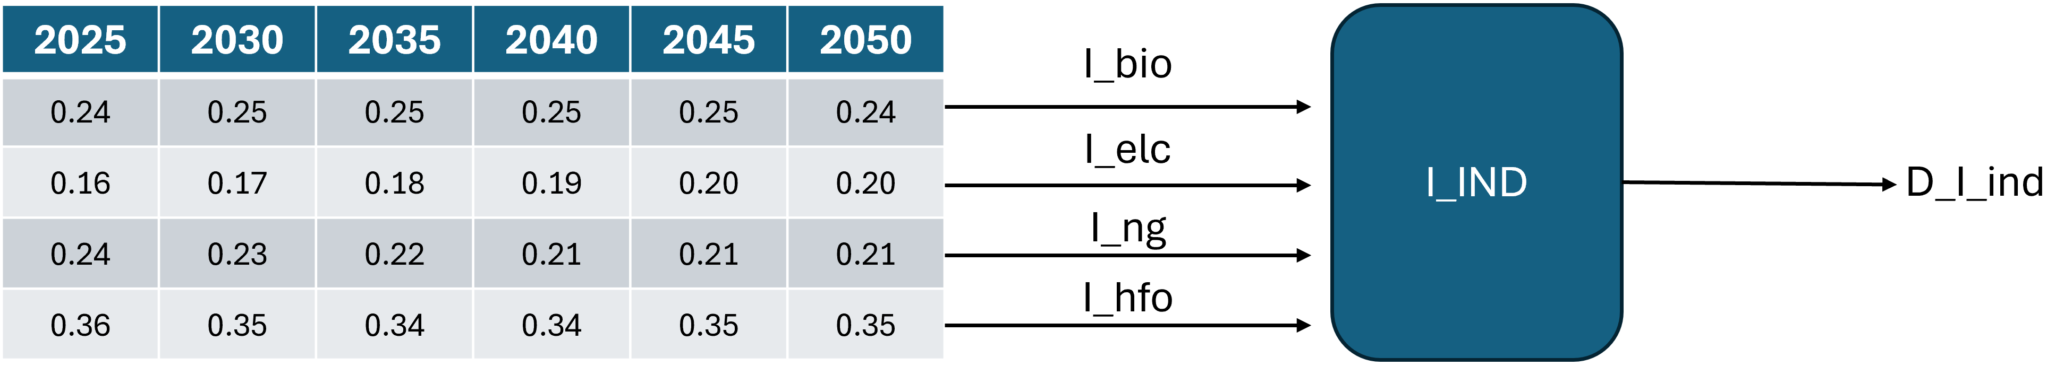
Nova Scotia:
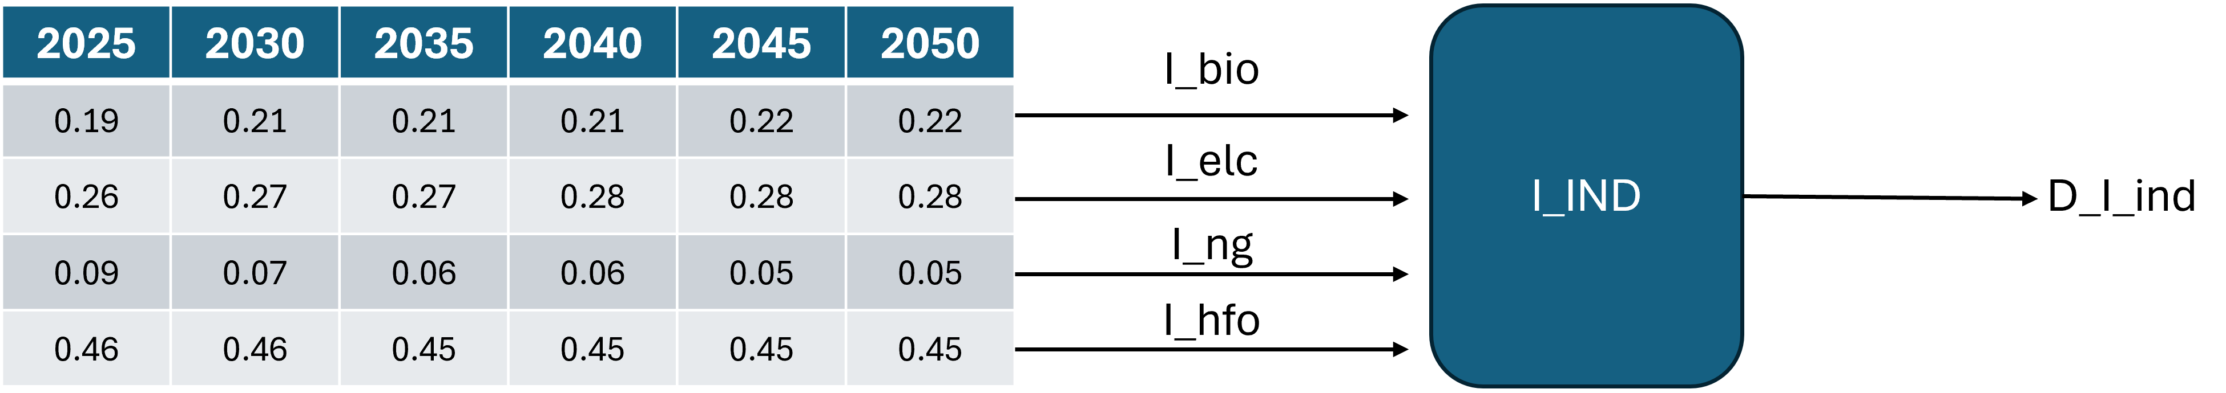
Tasks:
- Integrate industry into Nova Scotia and New Brunswick
- Ensure it follows breakdown shown in the figure above for all relevant tables.
- Once done, check that you have got everything correct.
Hints:
Hint 1: Assume the efficiency of the technology is 1, it makes the math easier as we don’t have an actual value for the output to go off.
Hint 2: Remember that Limittechinputsplitannual should be a percentage, i.e. 10% is 0.1, also that it cannot go above 100%/1 altogether.
Hint 3: Looking at the other technologies, the tags for unlim_cap and annual should be set to 1.
- Add Tech Groups and Policies
Something that has been added to the Temoa framework is the ability to group technologies into a group. It allows us to better control constraints related to groups rather than individual technologies. We can control new capacities, set max and minimum activities and more using technology groups.
The scenario for this activity: Both New Brunswick and Nova Scotia have agreed to have a certain amount of renewables make up the electricity grid in each of the different time periods.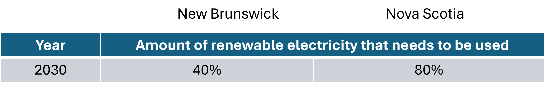
Tasks
- Create an appropriate group for this scenario
- Create the appropriate constraints for this renewable electricity scenario
- Once done, check that you have got everything correct and that the model runs
Hints:
Hint 1: The table you need to use is RPSrequirement
Hint 2: You can pick the appropriate technologies as you see fit, for the base test case we used hydro, wind and solar as renewable sources.
Hint 3: If the model isn’t working, remember that RPSrequirement is a percentage value.
- Add direct air capture into the model.
There are only so many things that we can do to reduce carbon dioxide emissions, such as a higher amount of greener electricity and moving away from dirtier fuels. But at a certain point the model can’t get to zero emissions as some sectors use fossil fuels in every time period. One way to reduce carbon emissions is by using carbon capture technologies such as carbon capture and storage/utilization (CCU/S) and direct air capture (DAC).
New Brunswick and Nova Scotia are putting certain limits on emission activities, 5,000 k Tonnes for each province by 2050. To achieve this, the use of DAC is being implemented. Implement DAC into the model and constraint the emission activity to meet the provinces targets.
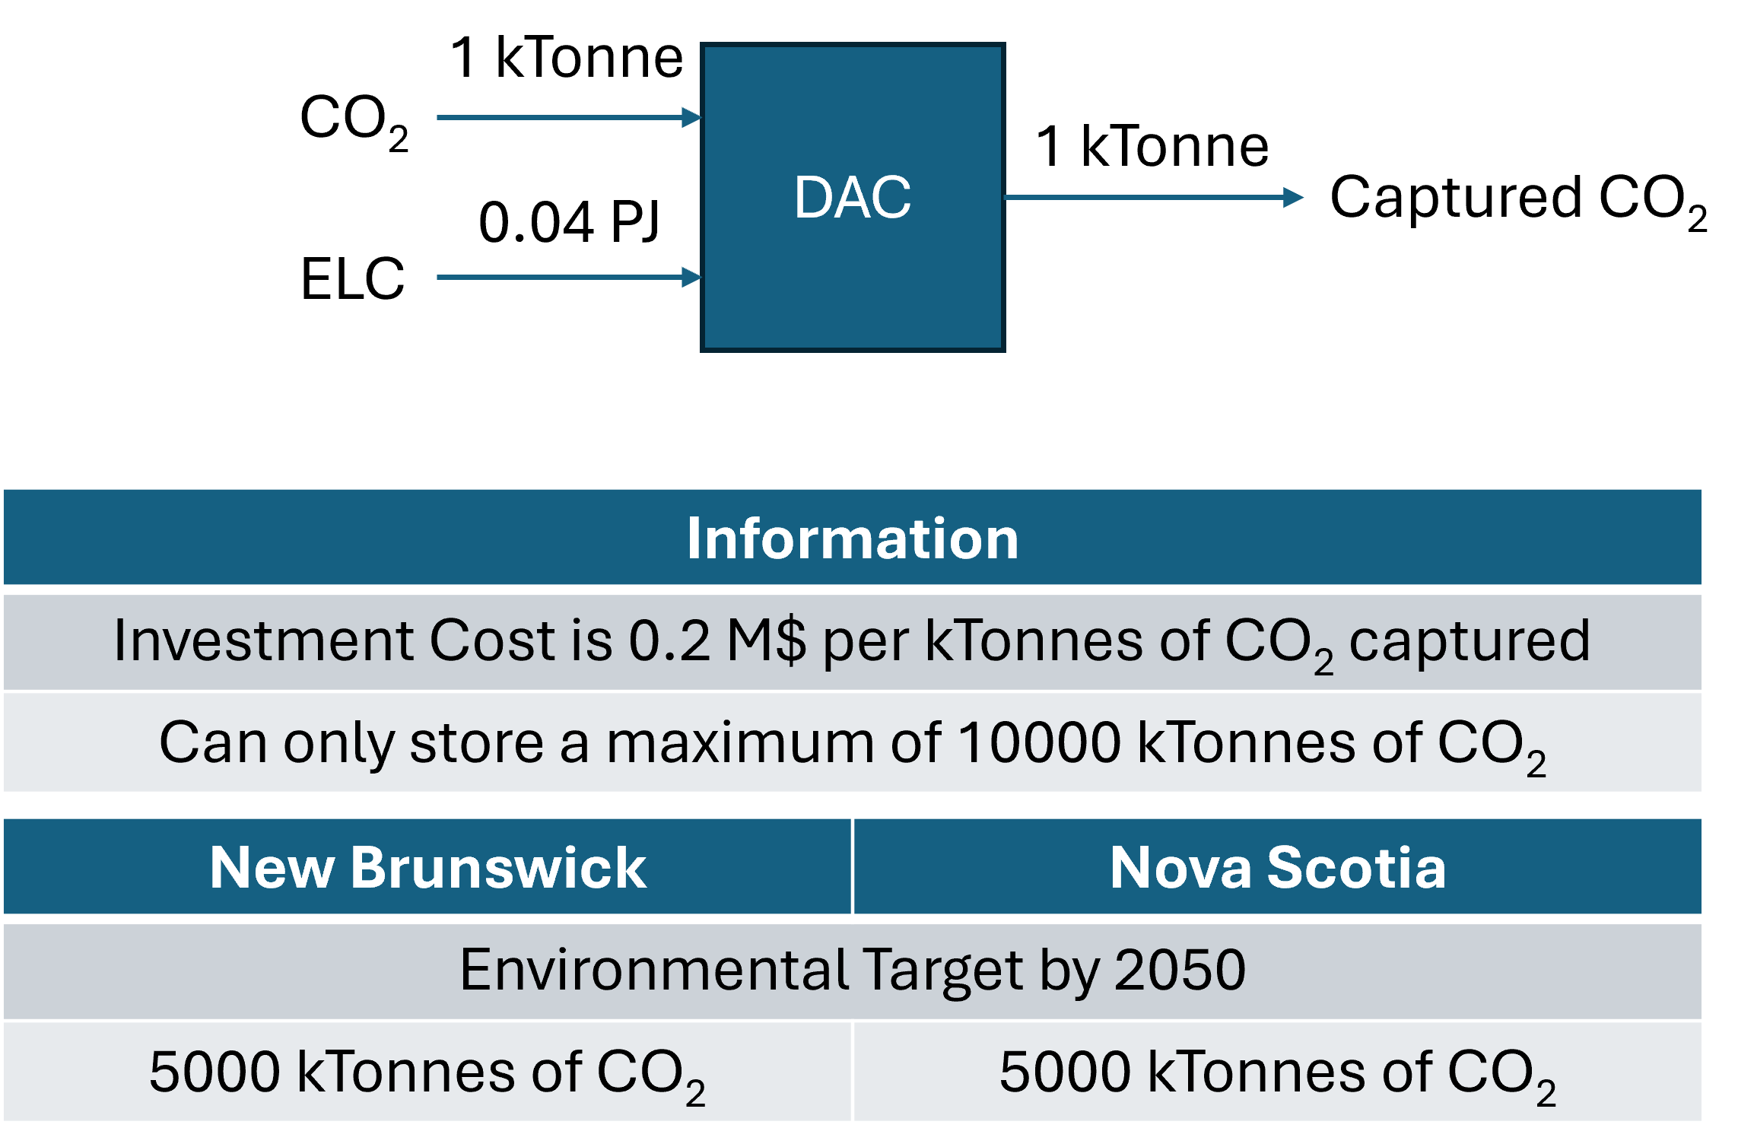
Tasks
- Create the constraint for the emission target
- Create the technology for DAC with the correct information
- Test the model to ensure that it works
Hints:
Hint 1: Emission constraint will be inputted in the LimitEmission table
Hint 2: Need to create waste commodity for captured CO₂
Hint 3: If model is unfeasible, check your emission activity and ensure it is a negative value.
- Complete efficiency assignment
This activity focuses on validating and correcting how the model translates mass/energy balance definitions into the OutputFlowIn table. The provided balance data includes a set of test systems that deliberately vary in complexity—some technologies have one input and one output, while others include multiple inputs, multiple outputs, or both. These cases are designed to surface issues such as missing rows, incorrect pairings between inputs and outputs, unintended double-counting, or incorrect scaling when more than one flow is present.
Your task is to run the provided test files, inspect the resulting OutputFlowIn entries, and update the logic so that the generated values match the expected values in the balance data spreadsheet for every test system.
Tasks:
- Review the balance spreadsheet to understand the expected input→output relationships and numerical values for each test case.
- Execute the scripts/files that generate the database outputs for those systems.
- Query and compare the OutputFlowIn table against the spreadsheet, case by case.
- Diagnose discrepancies (e.g., wrong row structure, incorrect mapping of flows, duplicated records, missing combinations, or incorrect calculated values).
- Adjust the implementation so the OutputFlowIn results are correct across all configurations, then re-run the full set of cases to confirm nothing regresses.
Hints:
Hint 1: Start with the simplest 1-input/1-output case to confirm the baseline logic is correct, then move to multi-input and multi-output cases.
Hint 2: If confused, check the onboarding document in the efficiency section.
for import and FINAL should be 1

